How to increase size of EBS Volume
- Instance has been created with root and EBS volume
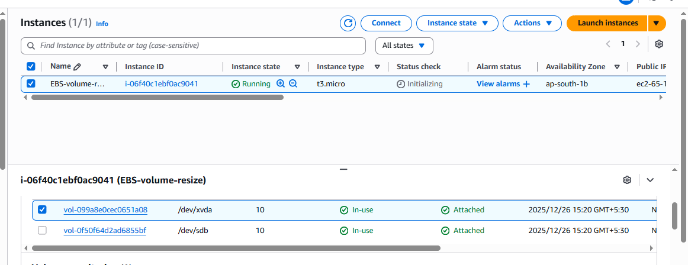
- Mount EBS Volume to particular directory

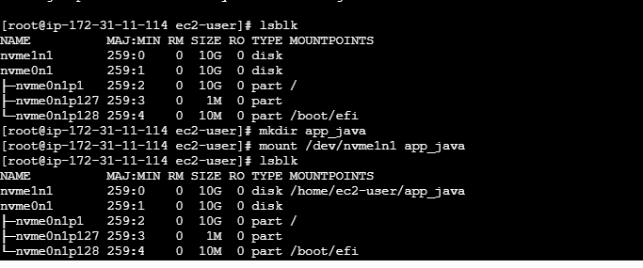
EBS volume mounted successfully and create to one sample file inside the mounted directory
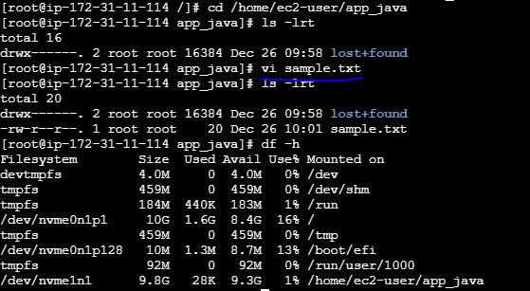
Modify EBS volume and increase the size

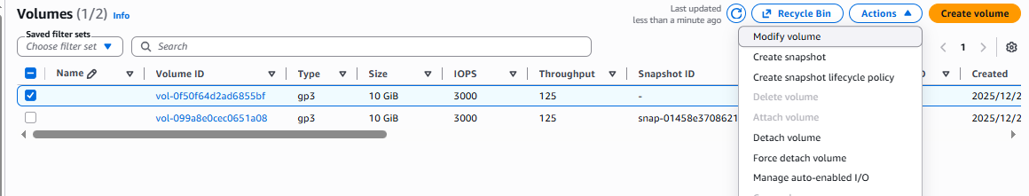
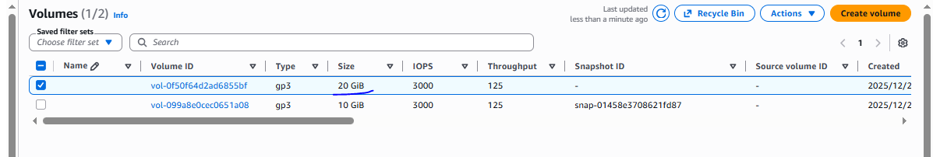

once increase the EBS volume size need to resize the disk using resize2fs /dev/nvme1n1 command
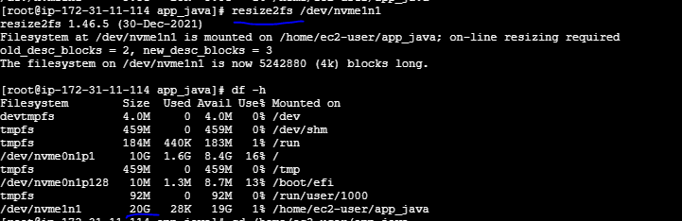
Data also present

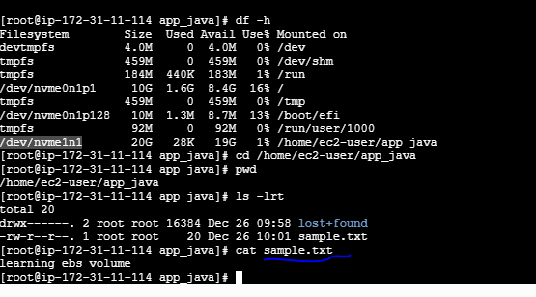

=======================How to attached available volume to other instance=====
Instance created with root EBS volume
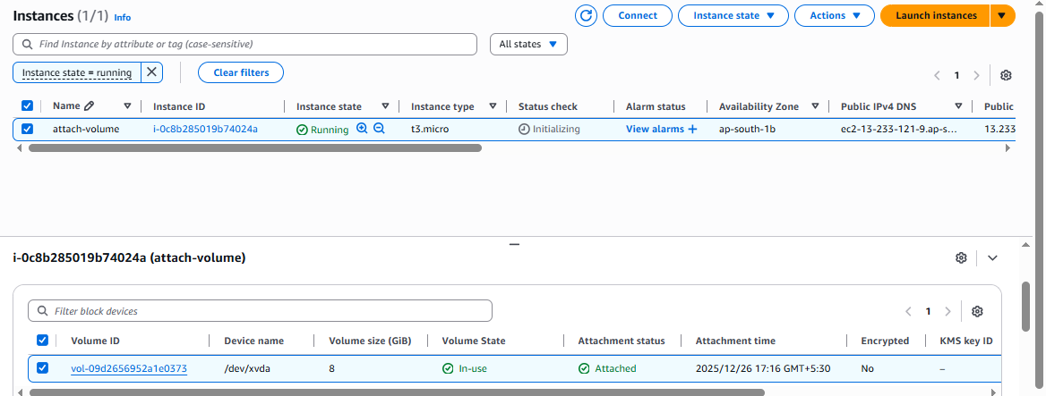

Available Volume
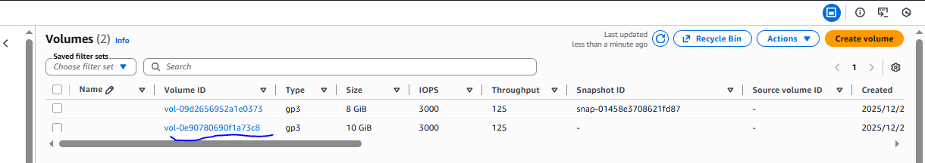

Attached available volume to instance
